Preparation of an Extended Abstract for the Lightning Talk & Demo Track of ICSSA 2017

Author¹, Author¹, Author^{2*}
¹Affiliation, ²Affiliation
*Corresponding author’s e-mail

SUMMARY
The summary is a synopsis of your two-page extended abstract for the lightning talk & demo track of the 3rd International Conference on Software Security and Assurance (ICSSA 2017). It should have an overview of your 10-minute presentation and provide the readers with results and findings of the research.

Keywords: Add up to 5 keywords

I. INTRODUCTION
These instructions give you basic guidelines for preparing a two-page extended abstract for the lightning talk & demo track of ICSSA 2017.
Please follow these instructions as closely as possible to assist in publishing a uniform digest. These instructions have been prepared in the preferred format.

II. HOW TO FORMAT THE PAGE

A. Page Size and File Format
Prepare your two-page extended abstract on a Letter size paper 8 1/2" x 11" (21.5cm x 27.9cm). Do not use A4 size paper, as this will cause formatting problems. Submit the Microsoft Word file of your paper.

B. Fonts
Best results will be obtained if you use Microsoft Word or a word-processing program with several font sizes. Try to follow the font sizes specified in Table 1. As an aid to gauging font size, 1 point is about 0.35 mm. Use the Arial font.

C. Margins and Formats
In formatting your paper, set the top margin to 0.85 inch (22 mm), bottom margin to 1.25 inch (32 mm) and left and right margins to 0.9 inches (22.8 mm). The column width is 3.22 inches (82 mm) with 0.3 inches (7 mm) space between the two columns. It is best to simply use this template.
You should left- and right- justify your columns. Use automatic hyphenation if you have it. Please adhere to American English spelling conventions. Please do not number this page.

III. ILLUSTRATIONS
You can include at most 2 figures and 2 tables as needed. Figure captions should be below the figure; table captions should be above the table.

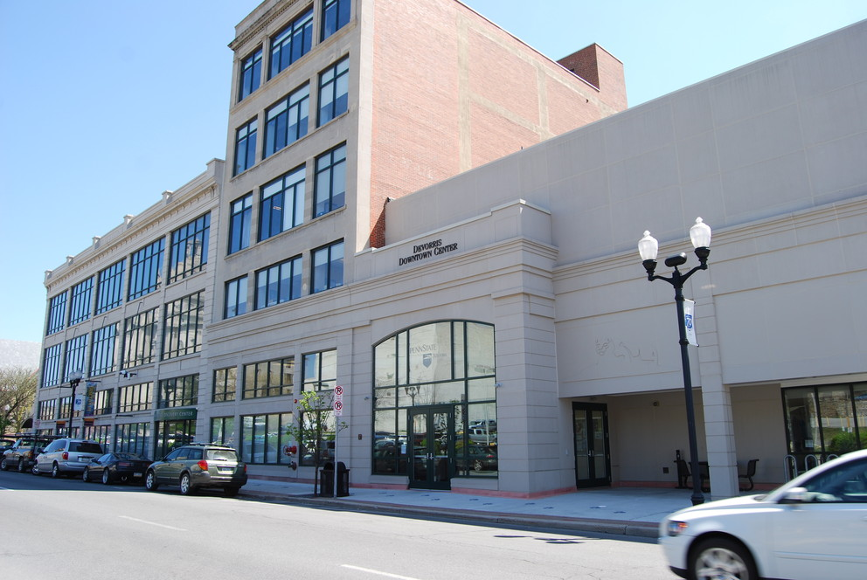
Figure 1: ABC

Table 1: Font Styles for Camera-Ready Paper
Size | Bold | Italic | Text Type (example)
14 | Yes |  | Paper Title
12 |  |  | Presenter’s Name
10 |  |  | Presenter’s Affiliation
10 |  |  | Authors’ List
10 | Yes |  | Headings (SUMMARY)
10 |  | Yes | Subheadings (B. Fonts)
10 |  |  | Main Text
ACKNOWLEDGEMENTS
Add appropriate acknowledgements as needed.

REFERENCES
- Authors, “Title of the Article,” Reference Information such as Journal or Conference Proceedings, Vol. X, No. Y, pp. 0000-1111, 2013.

